## horizontal line



Road Lines Detection Using Data Science

27/04/2022

**─**

Saptarshi Patra

MCA, Information Technology Dept,

Makaut University,

Reg No- 201000571010039

Roll No- 10071020039

# Overview

Being able to detect lane lines could be a crucial task for any self-driving autonomous vehicle. In this project, to identify lane lines on the road OpenCV is used. OpenCV method uses the input images to find any lane lines command among and also for rendering out an illustration of the lane. The OpenCV tools like color selection, the region of interest selection, gray scaling, Gaussian smoothing, Canny Edge Detection, and Hough Transform line detection are being employed. A colour detection algorithm identifies pixels in a picture that matches a given color or colour range. Region of interest selection allows you to select a rectangle in an image, crop the rectangular region and finally display the cropped image. Gray scaling is the method of changing an image from different colour spaces e.g. RGB, CMYK, HSV, etc. to shades of gray. In gaussian Blur operation, the image is convolved with a mathematician filter rather than the box filter. The Gaussian filter could be a low-pass filter that removes the high-frequency elements. Canny Edge Detection is used to detect the edges in a picture. It accepts a grayscale image as input and it uses a multi-stage algorithm. The Hough Transform line is a method that is used in image processing to detect any shape if that shape can be represented in mathematical form. The goal is to piece along a pipeline to detect the line segments within the image, then average/extrapolate them and draw them onto the image for the show.

# Advantages

1. We can apply computer vision to self-driving cars.
2. This system ensures drives don’t move out of their lanes.
3. This algorithm can also detect road lines for a video also.

# Disadvantages

1. If the road lines are inconsistent then the whole algorithm may face a lot of troubles.
2. Also requires active internet connection for self-driving cars.

# Project Development Used Technologies

## Technology Stack

1. Programming Language - Python3
2. Libraries - OpenCV, Matplotlib, Anaconda

## Version Control System

Git and Git-Hub

# Project Development Progress

The screenshot of project development progress is attached below -

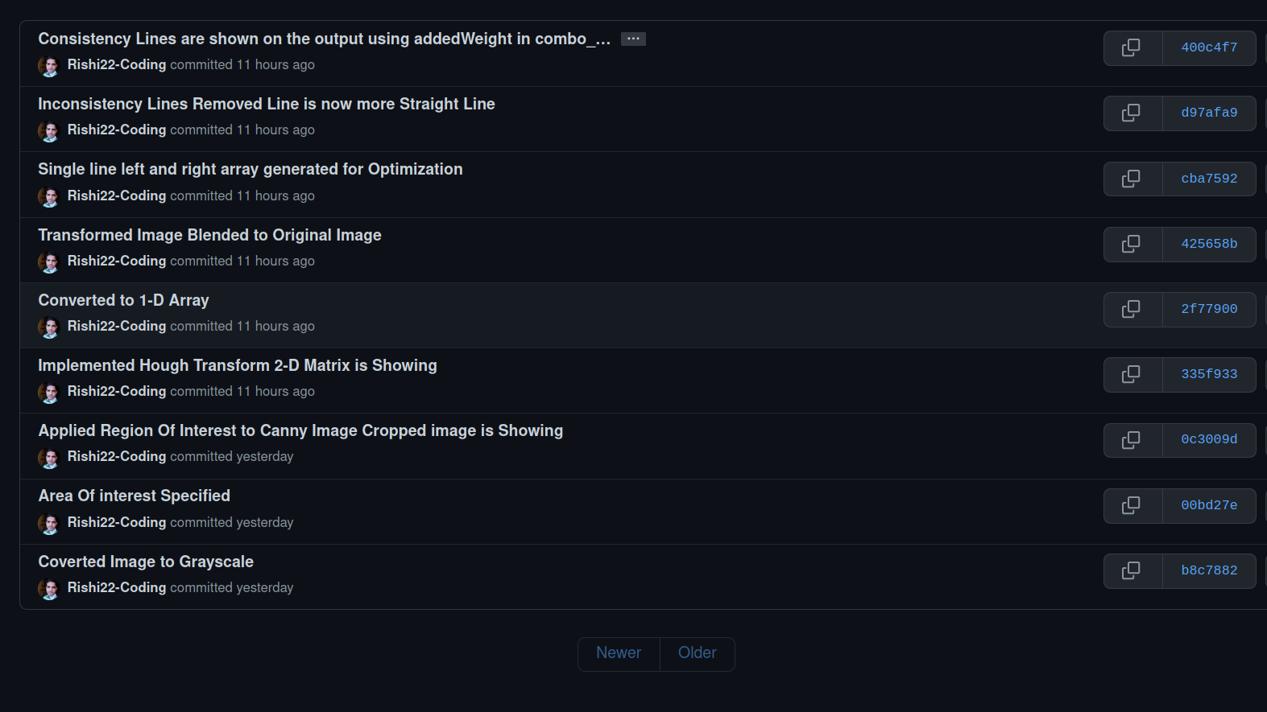

# Project Development Process

## Taking the Image -

* 1. We can take any image from the internet, to be specific the road lines should be visible clearly.
  2. .png image quality will be the best for that. PNG is the Higher Compression format for images.
  3. For development purpose i took below image from the internet -

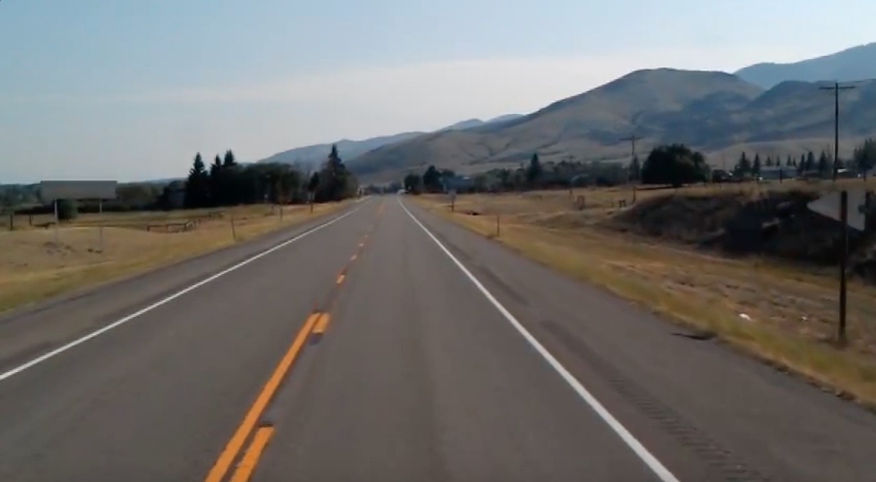

## Converting the Image to Gradient -

1. Measure of change in brightness over adjacent pixels. For an example Strong Gradient —---> 0 — 255 —---> Measures Stiff Change. Small Gradient —---> 0 — 15 —---> Measures Sallow Change.
2. Why Should We Convert Our Image onto GrayScale ?

Images are made up of pixels, A 3 Channel color image Red, Green, and Blue (RGB) Channel has three intensity values in each pixels.

Whereas, Grayscale Image only has 1 channel each pixel of this image has only 1 intensity values ranging from 0 —> 255.

1. After converting the image to grayscale the output of the image is attached below -

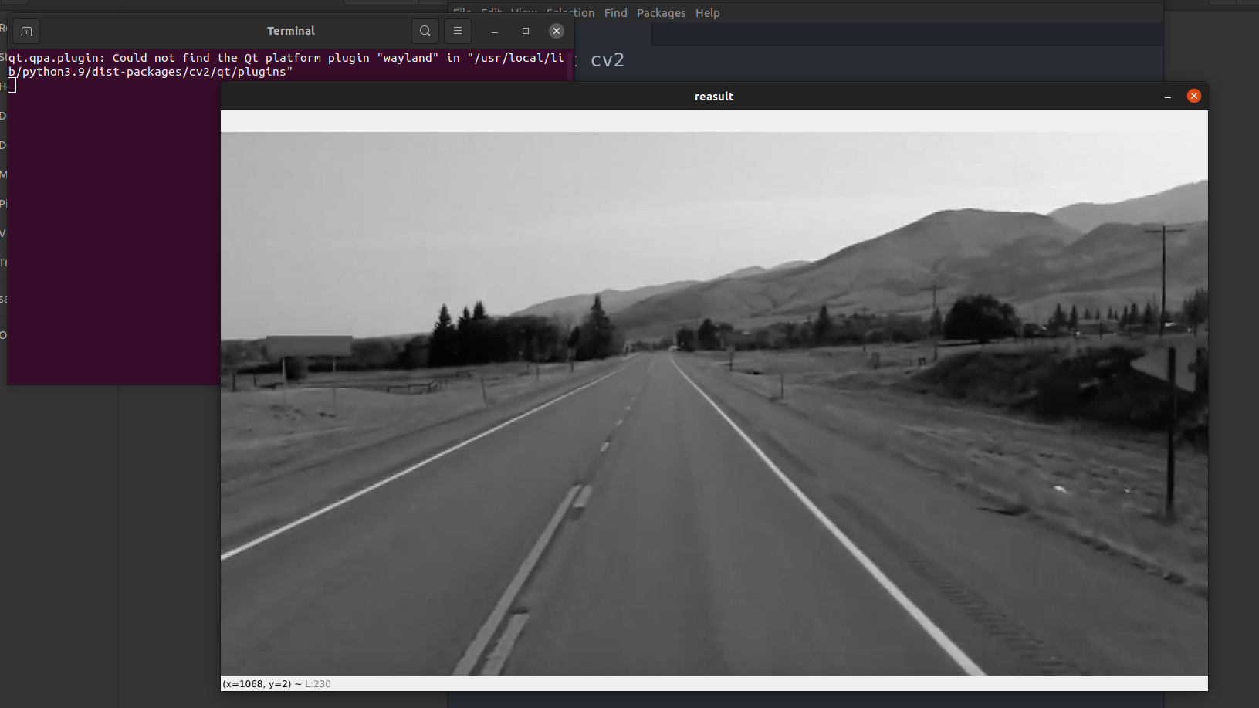

1. The advantage of using a grayscale image is, GrayScale Image is faster than processing a RGB Image or any 3 Channel or more Channel like CMYK color image. That's why We are getting an edge in Computational Advantage.
2. For this the System will run more efficiently.

## 

## Applying Canny Method -

1. The Canny edge detector is an edge detection operator that **uses a multi-stage algorithm to detect a wide range of edges in images**. It was developed by John F. Canny in 1986. Canny also produced a computational theory of edge detection explaining why the technique works.
2. In an image x represents the width of an image. Width represents the number of columns in the image, height represents rows in the image.
3. Canny method is used to detect edges in an image.
4. Canny Edge Detection Algorithm is an algorithm of 4 major steps -
5. Reduce Noise using Gaussian Smoothing.
6. Compute Image gradient using sobel filter.
7. Apply non-matrix suppression or NMS to just keep the local maxima.
8. Finally, apply Hysteresis Thresholding which that by passing 2 Threshold values upper and lower in the canny function.
9. Working -
10. If the gradient is larger than the upper threshold it will be accepted as edge pixel.
11. If the gradient is below the lower threshold then it will be rejected.
12. If the gradient is between of lower and higher threshold then it will be accepted only if it is connected to a strong edge.

## Specifying Region of Interest -

## A region of interest (ROI) is a portion of an image that you want to filter or operate on in some way. You can represent an ROI as a binary mask image. In the mask image, pixels that belong to the ROI are set to 1 and pixels outside the ROI are set to 0. The toolbox offers several options to specify ROIs and create binary masks.

1. Generated a triangular Polygon.
2. After that we can show our Region of Interest in our Canny Image, For that purpose we have to use the BITWISE AND Operations into the array.
3. Output after specifying area of interest is attached below

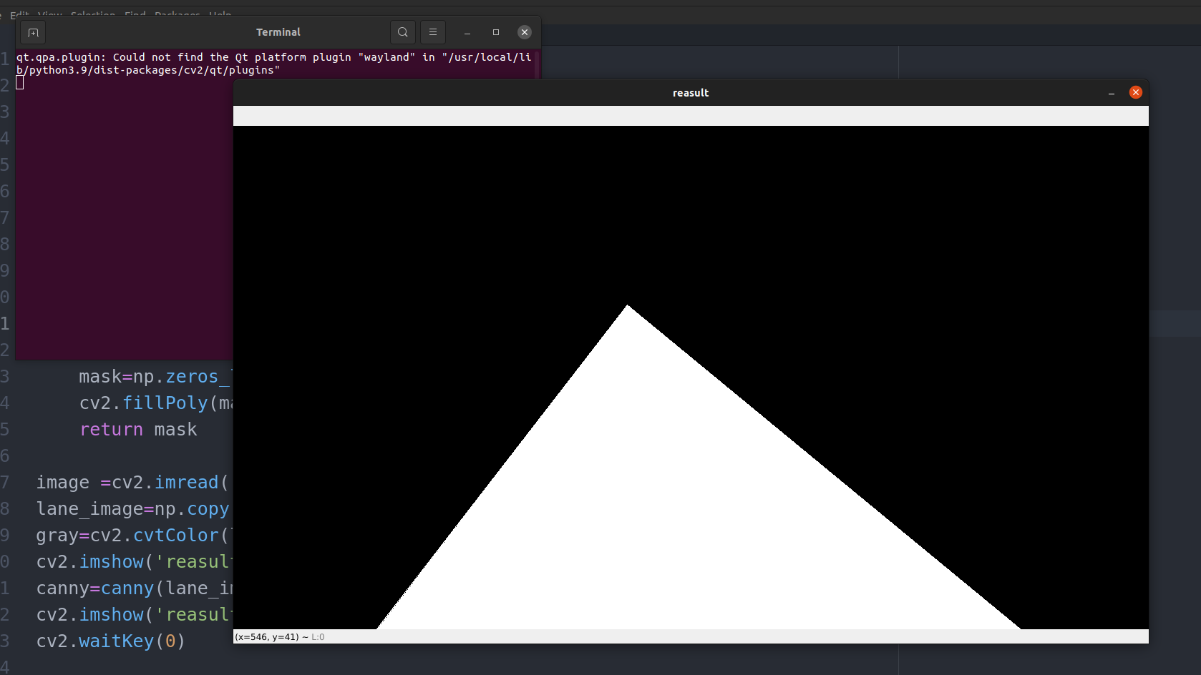

1. Output Area of interest Cropped Image is attached below

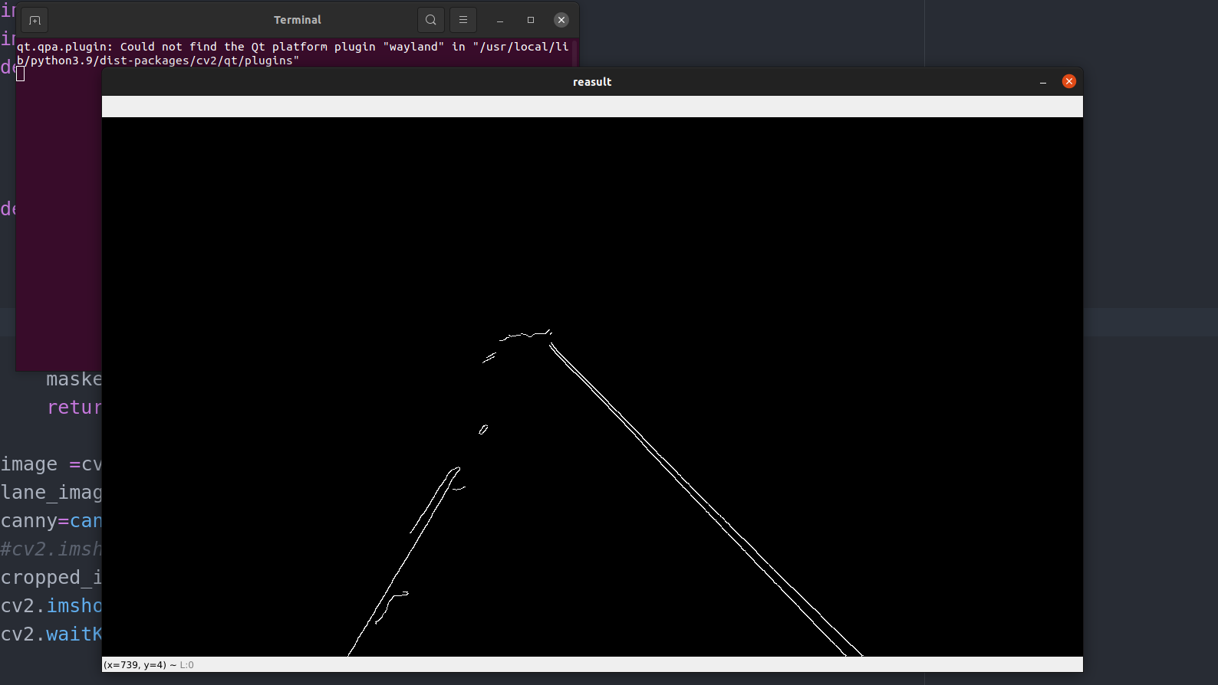

## Hough Transform Technique to Detect Straight Line of an Image -

1. The Hough Transform is a method that is used in image processing to detect any shape, if that shape can be represented in mathematical form. It can detect the shape even if it is broken or distorted a little bit.
2. A line can be represented as y = mx + c or in parametric form, as r = xcosθ + ysinθ where r is the perpendicular distance from origin to the line, and θ is the angle formed by this perpendicular line and horizontal axis measured in counter-clockwise ( That direction varies on how you represent the coordinate system. This representation is used in OpenCV).
3. Working of HoughLine Method -
4. First it creates a 2D array or accumulator (to hold values of two parameters) and it is set to zero initially.
5. Let rows denote the r and columns denote the (θ)theta.
6. Size of array depends on the accuracy you need. Suppose you want the accuracy of angles to be 1 degree, you need 180 columns(Maximum degree for a straight line is 180).
7. For r, the maximum distance possible is the diagonal length of the image. So taking one pixel accuracy, number of rows can be diagonal length of the image.
8. To apply a houghline method, first an edge detection of a specific image is required.
9. Output after Implementing Hough Transform 2-D Matrix

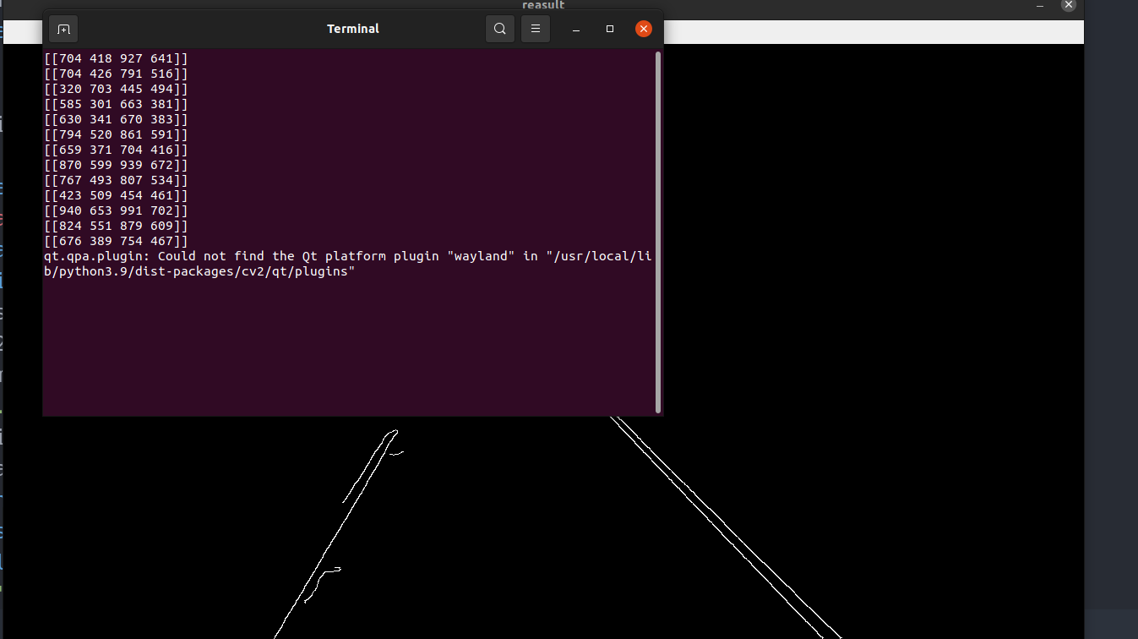

1. Output after converting 2-D Matrix to 1-D Array Inconsistent line is Showing

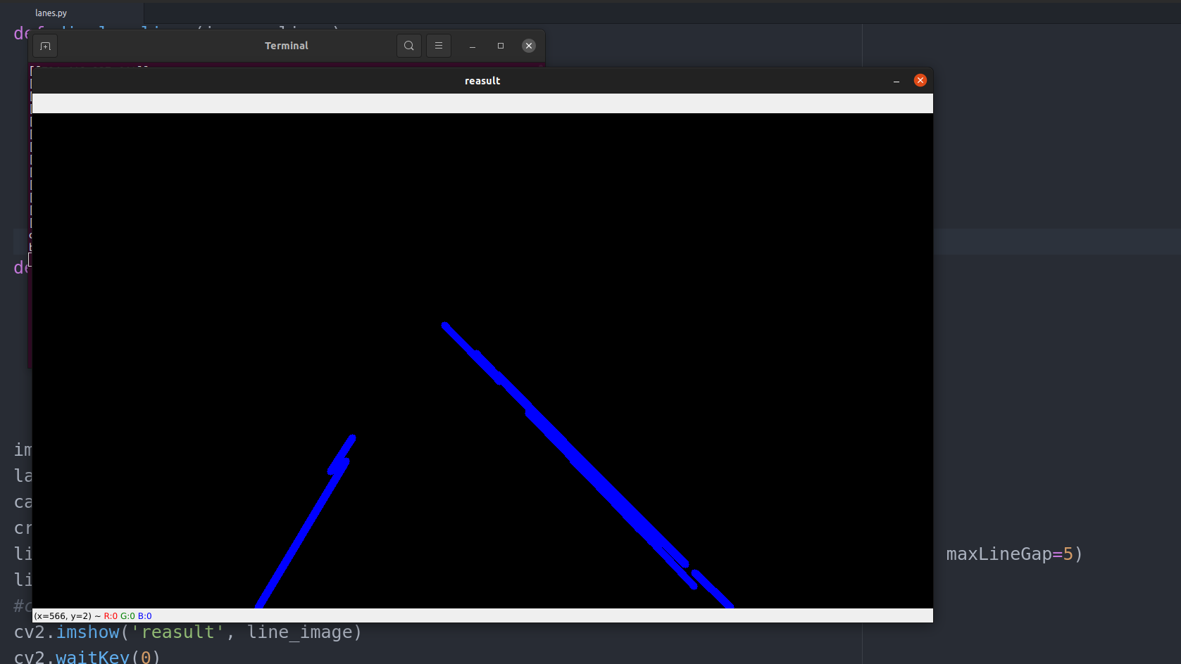

1. Output after blending the inconsistent line image to our original image

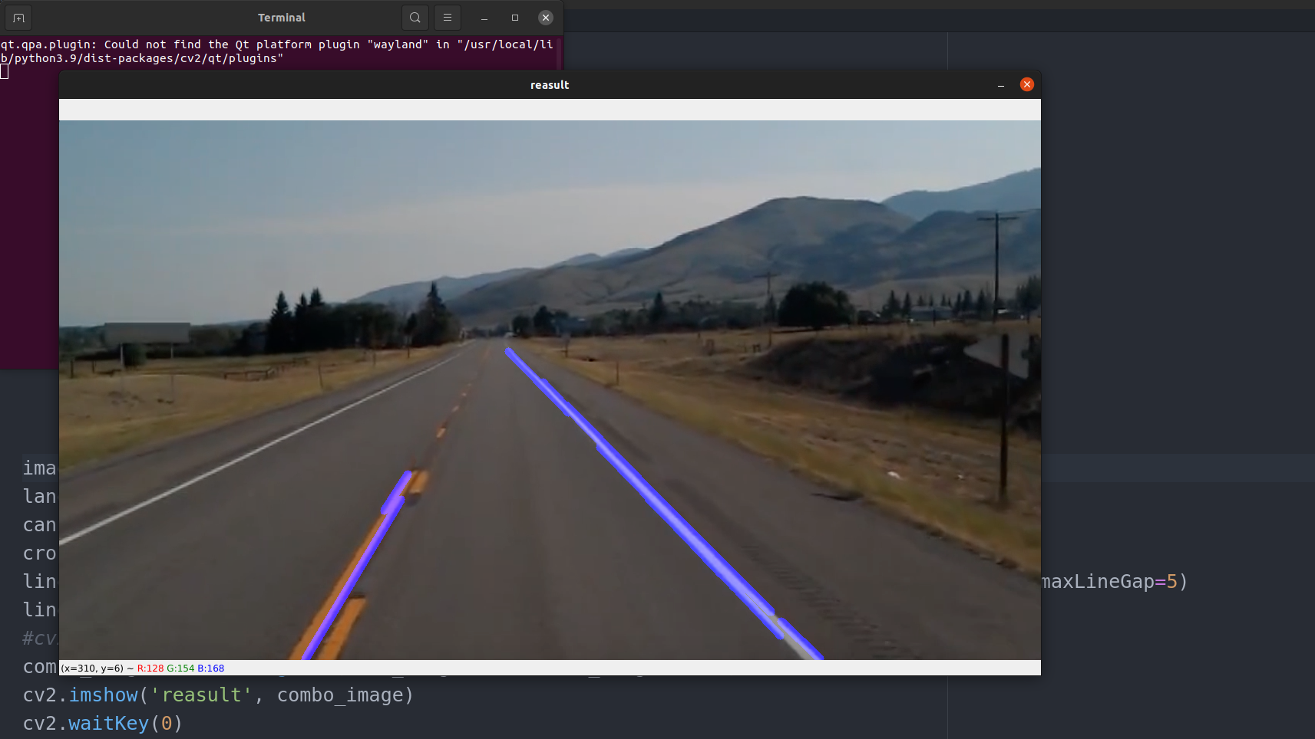

## Optimization of Blended Image to Original Image -

1. Output of Single line left and Right array generated for Optimization

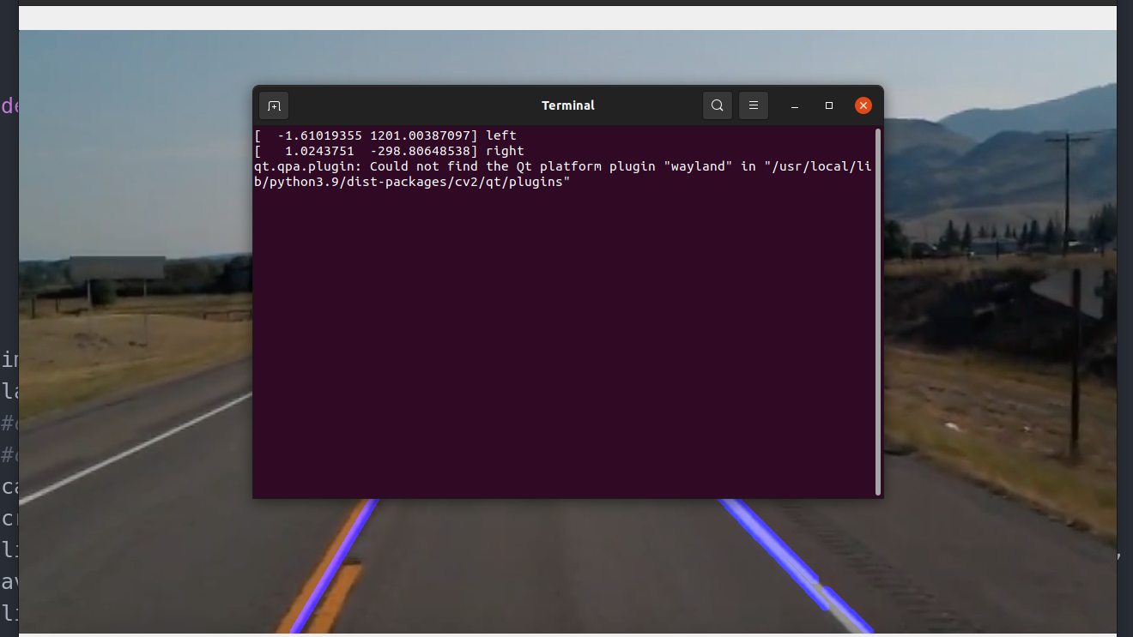

1. Output of Straight Line generated

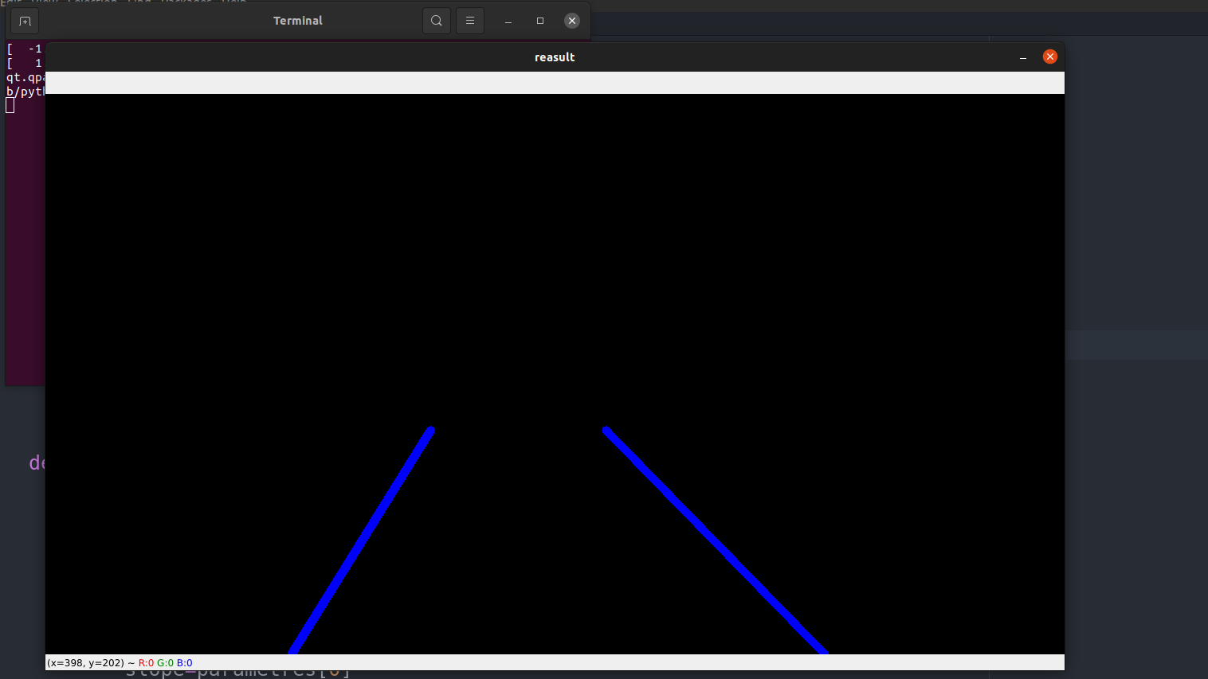

1. Output of Combined Straight Line and Original Image

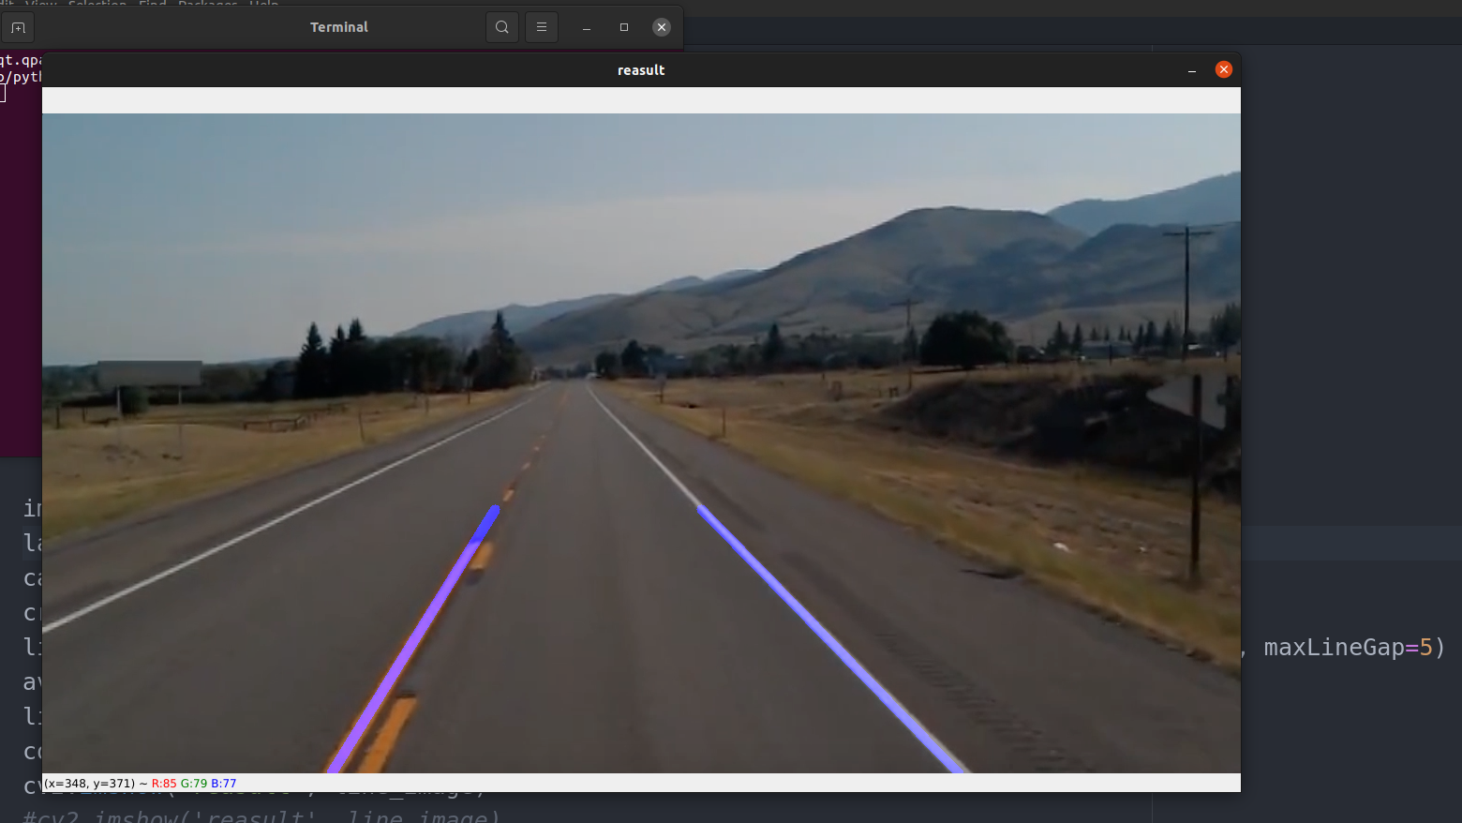

# After Developed Last Commit Message in Git & Git-Hub